Writing Ideas
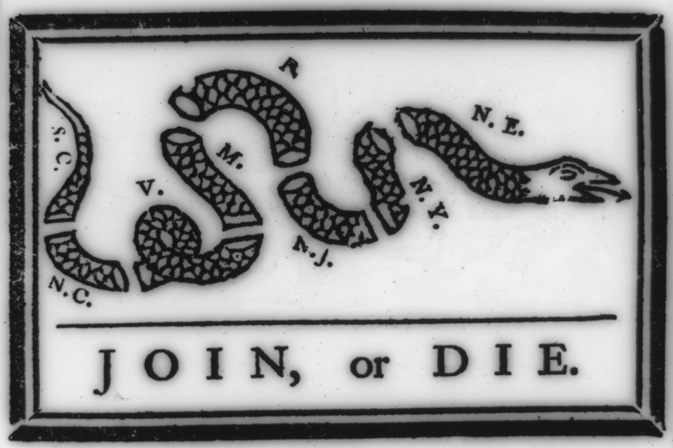

The Remarkable Cause
A Novel of James Lovell and the Crucible of the Revolution

by Jean C. O’Connor

The ideas in The Remarkable Cause lend themselves to written analysis and exploration. Conflict, endurance, love of country, friendship, all are part of the story of these early Americans.

Writing Focus Statements:
- The Common Core identifies three main forms of writing: Argumentative, Explanatory, Narrative. You will find examples of writing focus statements for each of these below. A more basic and a more complex writing focus statement is given for each.

- For information on writing and related topics, see Purdue Owls.

- Here you will find guidance for the three main forms of writing, and a fourth, Description.

- Follow the steps in the writing process, including brainstorming, planning, drafting, revising, and editing.

- Additional research may be necessary to respond in written form to any of these questions. See the Annotated List of Sources for Research, at this Study site.

Writing Focus Statements for
The Remarkable Cause: A Novel of James Lovell and the Crucible of the Revolution
Argumentative
Does Benjamin Franklin’s woodcut of a severed snake, representing the thirteen colonies, show the problem facing the American colonists during the years before the American Revolution, or is it a cleverly stated piece of propaganda convincing them they needed to join together? Take a stand and support your opinion with evidence.

Benjamin Franklin’s woodcut graphically illustrates the position of the thirteen colonies at the outset of the American Revolution. Unless they worked together, they would be severed from the whole, as if a snake were cut up into thirteen pieces. Does this metaphor explain why the troubles experienced in Boston overflowed into protests in other colonies, such as those in New York, and to efforts to work together, such as the Stamp Act Congress? Or is there another dynamic at work here, such as economic factors, pressure from Boston for assistance, or scheming by political leaders? Why do you think the colonies began to work together, even though Boston was the first to be occupied by soldiers?
Explanatory
Have you ever had an argument with someone with whom you needed to get along? How did you solve the problem? What are some of the ways James Lovell and his father, Master John Lovell, choose to get along despite their differences? Are these ways effective?
James Lovell and his father, Master John Lovell, disagree about attitudes towards the British and their persistence in taxing the American colonists. Yet despite their disagreements, they are willing to work together, even to enjoy time together with their families. Consider at least three times in The Remarkable Cause: A Novel of James Lovell and the Crucible of the Revolution when James and his father manage to override their disputes. Explain what habits or practices each of the two demonstrate in these situations in order for their relationship to remain cordial. How can similar habits or practices help us to get along with those with whom we disagree today?
Narrative
Imagine that you are one of the people in The Remarkable Cause: A Novel of James Lovell in the Crucible of the Revolution. Tell the story of one of the events from your point of view. You may write a letter to a friend or relative, a journal entry, or a narrative. Be sure to explain how you felt, and what you saw and heard.
Choose one of the events depicted in The Remarkable Cause: A Novel of James Lovell in the Crucible of the Revolution. Research and create a list of at least ten facts for the event. Using the facts, tell the story of the event from the point of view of a character who participated in the event, or from the point of view of a bystander. Use descriptive words and phrases, remembering the five senses: What would you hear? See? Smell? Taste? Feel? Write the narrative piece in the form of a journal, diary, letter, speech, editorial, dialogue, dream, or other prose form. Tell the events as they happened.
And--Compare / Contrast, a variation
Demonstrations, marches, protests of various kinds in pre-Revolutionary Boston showed the attitudes of the people towards the taxes imposed on them by the British. How are the forms of protest described in The Remarkable Cause: A Novel of James Lovell and the Crucible of the Revolution the same as those that occur today? How are they different?

Image Source: "Join or Die." Franklin, Benjamin, 1706-1790. The Pennsylvania gazette, 1754 May. Library of Congess Prints and Photographs Online. hdl.loc.gov/loc.pnp/cph.3a12149

